# **📨 The Market Signal Inbox: Your Digital Reception Center**

## **Introduction**

Your Market Signal Inbox is the front-line collection center of your Billion-Person Focus Group system - where raw insights from across the digital landscape are captured before they can be processed into meaningful intelligence. Think of it as the nervous system of your organization, receiving signals from everywhere your digital senses are active.

In this guide, we'll walk through:

* What belongs in your Signal Inbox (and what doesn't)
* How to choose between Airtable and Notion for your signal collection
* How to structure your Signal Inbox around the Five Digital Senses framework
* Step-by-step setup instructions for both platforms

Let's start building your digital sensing infrastructure!

## **What Belongs in Your Signal Inbox?**

Your Signal Inbox should capture raw, unprocessed signals from the digital world that have emotional, cultural, or strategic relevance to your market. These are fragments that, on their own, might not tell the full story - but when collected and connected over time, reveal meaningful patterns.

### **Include in Your Signal Inbox:**

✅ **Emotional reactions**: Comments, reviews, or social interactions that carry strong emotional charge

✅ **Linguistic shifts**: New terms, phrases, or ways of describing experiences in your category

✅ **Visual trends**: Emerging aesthetics, visual styles, or design patterns

✅ **Behavioral indicators**: How people are using products, services, or digital spaces in unexpected ways

✅ **Competitor movements**: Updates, launches, or messaging shifts from competitors

✅ **Cultural tensions**: Contradictions, frustrations, or unmet needs expressed by your audience

✅ **Weak signals**: Early indicators of potential change that haven't yet gone mainstream

### **Don't Include:**

❌ Fully processed research or reports (these go in your Second Brain)

❌ General industry news without emotional or behavioral relevance

❌ Quantitative metrics without qualitative context

❌ Content you've created (vs. observed in the wild)

❌ Random information without potential market relevance

## **Airtable vs. Notion for Signal Collection**

Both platforms have strengths for building your Signal Inbox, but they serve different working styles and future automation needs.



### **Airtable Strengths:**

* Stronger structured database capabilities
* More robust filtering and sorting options
* Better for complex relational data
* More powerful integration with n8n and other automation tools
* Better for larger datasets and teams
* Superior views (Kanban, Gallery, etc.) for visualizing patterns

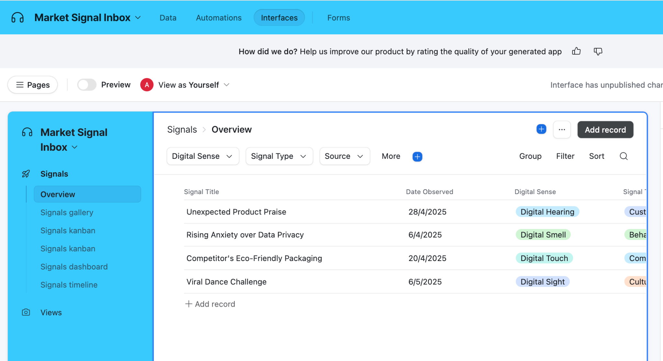

### **Notion Strengths:**

* More intuitive for beginners
* Built-in AI for faster signal analysis
* Better for narrative context and writing
* Excellent Web Clipper for rapid signal capture
* Easier to combine structured and unstructured content
* Can embed multi-media content more seamlessly
* Better for individual or small team use

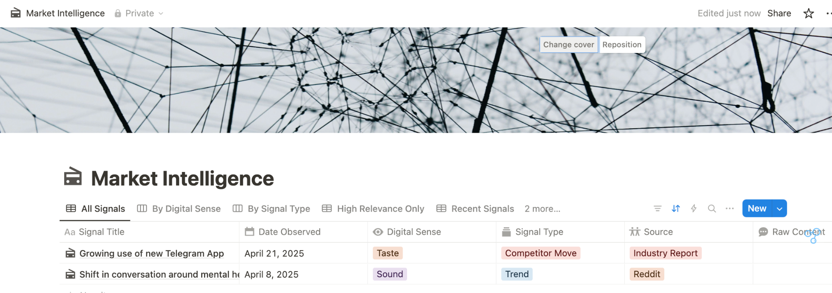

### **Recommendation:**

* **Choose Airtable** if you plan to heavily automate your system, work with large volumes of signals, or need complex relational capabilities.
* **Choose Notion** if you prefer a more intuitive interface, need strong writing/content capabilities alongside your database, or want built-in AI analysis.

## **Core Signal Taxonomy: The Five Digital Senses Framework**

Your Signal Inbox should be structured to capture insights across all five digital senses - your organization's way of perceiving what's happening in the market. Each signal you collect should be tagged with which sense detected it.

### **Digital Sight**

**Definition**: Visual and aesthetic signals detected through observation of images, videos, design, and visual culture.

**Examples**:

* Emerging visual styles in your category
* Changes in competitor visual identity
* New visual metaphors gaining traction
* Shifts in color palettes or typography trends
* Visual memes relevant to your industry

**Sources**:

* Instagram, Pinterest, TikTok
* Competitor websites and advertising
* Product packaging and design
* Trade show photos
* Industry publications

### **Digital Hearing**

**Definition**: Verbal and conversational signals detected through listening to how people talk about their experiences, needs, and desires.

**Examples**:

* New terminology to describe experiences
* Emotional language in reviews or feedback
* Questions people are asking
* Repeated complaints or praise
* Metaphors used to describe experiences

**Sources**:

* Reddit, Twitter, forums
* Customer service transcripts
* Reviews and testimonials
* Podcast discussions
* YouTube comments

### **Digital Touch**

**Definition**: Behavioral signals detected through observing how people interact with products, services, and digital environments.

**Examples**:

* Workarounds people create to solve problems
* How products are used in unexpected ways
* Friction points in user journeys
* Abandoned or adopted features
* Purchase behavior patterns

**Sources**:

* User testing videos
* Support tickets describing usage
* Reddit threads about "hacks" or workarounds
* App reviews describing behavior
* Social media posts showing product usage

### **Digital Smell**

**Definition**: Early-warning signals detected before they're obvious - subtle hints of emerging change that might become significant.

**Examples**:

* Small but passionate communities forming
* Early-stage complaints before they become widespread
* New competitors gaining niche attention
* Cultural micro-trends not yet mainstream
* Early backlash to established norms

**Sources**:

* Triggered Feedback Surveys
* App reviews
* Community boards (slack, discord etc)
* Local/regional social media
* Early adopter communities

### **Digital Taste**

**Definition**: Signals about what resonates and what people are drawn to - detecting desire, attraction, and stickiness.

**Examples**:

* Content that generates unusual engagement
* Products/features people become emotionally attached to
* What people share unprompted
* Cultural references gaining unexpected traction
* New desires or aspirations being expressed

**Sources**:

* Highly shared or saved content
* Engagement metrics with qualitative context
* Unsolicited recommendations
* Aspiration-focused platforms (Pinterest, etc.)
* Influencer content with high response

## **Setting Up Your Market Signal Inbox**

Now let's build your actual Signal Inbox in either Airtable or Notion. Both platforms follow a similar conceptual structure, with some platform-specific customizations.



### **Using Airtable**

### 

### **Option 1: Setting Up Your Signal Inbox in Airtable - (Start from Scratch)**

1. **Create a new base** called "Market Intelligence" or "Signal Inbox"
2. **Rename your first table** to "Raw Market Signals"
3. **Set up your core fields**:
   * **Signal Title** (Primary Field): A short descriptive title for the signal
   * **Date Observed** (Date): When you encountered this signal
   * **Digital Sense** (Single Select): Which of the five senses captured this signal
   * **Signal Type** (Single Select): Categories like Trend, Customer Comment, Competitor Move, Visual Change, etc.
   * **Source** (Single Select): Where you found this signal (Reddit, TikTok, Customer Interview, etc.)
   * **Raw Content** (Long Text): The actual text, description, or reference to what you observed
   * **Attachment** (Attachment): Screenshots, images, or media related to the signal
   * **Emotional Tone** (Single Select): The dominant emotion expressed (Excitement, Frustration, Curiosity, Fear, etc.)
   * **Relevance Score** (1-5 Rating): How potentially important this signal might be
   * **Notes** (Long Text): Any additional context or thoughts you want to add
4. **Create Views for different perspectives**:
   * **All Signals** (Grid View): Everything in chronological order
   * **By Digital Sense** (Kanban View): Group by which sense detected it
   * **By Signal Type** (Kanban View): Group by trend, feedback, competitor move, etc.
   * **High Relevance** (Grid View): Filter to show only signals rated 4-5
   * **Recent Signals** (Grid View): Only the last 30 days
   * **Visual Gallery** (Gallery View): Image-focused view using the Attachment field
5. **Create a Form for quick signal capture**:
   * Click "+ Create Form" from your table view
   * Configure the form with essential fields for quick entry
   * Bookmark this form on your devices for easy access

### 

### **Option 2: Build and App Using AI (recommended)**

Why build from scratch when you can leverage AirTable’s internal AI Co-builder tool

[Click here to see this in action.](https://screen.studio/share/t8yIcDEg)

You will end up with fully fledged signal inbox that you can use to manually enter signals or to based your n8n automations off later:



Here are some prompts you can put in Airtable’s AI Co Builder- this will allow you to:

1. Get a functioning Signal Inbox set up in minutes
2. Customize it to your specific business context
3. Focus on the actual work of collecting signals rather than database design
4. Learn the structure through using a well-designed system

## **Starter Templates**

## **Starter Prompt 1: Basic Market Signal Inbox**

| Create a Market Signal Inbox with these fields:  - Signal Title (Primary Field)  - Date Observed (Date)  - Digital Sense (Single Select): Digital Sight, Digital Hearing, Digital Touch, Digital Smell, Digital Taste  - Signal Type (Single Select): Customer Comment, Competitor Move, Visual Trend, Behavioral Pattern, Terminology Shift, Cultural Shift  - Source (Single Select): Social Media, Customer Support, User Testing, Competitor Website, Review Site, Forum  - Raw Content (Long text)  - Attachment field  - Emotional Tone (Single Select): Excitement, Frustration, Anxiety, Confusion, Delight, Disappointment, Trust, Skepticism, Neutral  - Relevance Score (Number, 1-5)  - Signal Status: New, Under Analysis, Connected to Pattern, Actioned, Archived  - Notes (Long text)  Create views:  - All Signals (Grid)  - By Digital Sense (Kanban)  - By Signal Type (Kanban)  - High Priority (Filter: Relevance >= 4)  - Recent Signals (Last 30 days)  - Visual Gallery |
| --- |

## **Starter Prompt 2: Competitive Intelligence Inbox**

| Create a Competitive Intelligence Inbox with these fields:  - Signal Title (Primary Field)  - Date Observed (Date)  - Competitor (Single Select): [Add your competitors]  - Signal Category (Single Select): Product Launch, Feature Update, Price Change, Marketing Campaign, Partnership, Expansion, Funding, Leadership Change  - Source Type (Single Select): Website, Press Release, Social Media, Industry News, Customer Report  - Signal Description (Long text)  - Evidence (Attachment)  - Potential Impact (Single Select): No Impact, Low, Moderate, High, Critical, Opportunity  - Impact Timeframe: Immediate, Short-term, Medium-term, Long-term  - Strategic Response Required (Checkbox)  - Response Status: No Response, Monitoring, Planning, Executing, Completed  - Notes (Long text)  Create views:  - All Signals (Grid)  - By Competitor (Kanban)  - High Impact Changes  - Requires Response  - Recent Movements |
| --- |

## **Starter Prompt 3: Customer Feedback Signal Inbox**

| Create a Customer Feedback Inbox with these fields:  - Feedback Title (Primary Field)  - Date Received (Date)  - Channel (Single Select): Email, Chat, Phone, Social Media, App Review, Third Party Review, NPS Survey, User Testing  - Customer Segment (Single Select): New User, Established User, Power User, Enterprise, SMB, Freemium, Churned  - Feedback Category (Single Select): Product Feature, UX, Performance, Pricing, Customer Service, Onboarding  - Feedback Type (Single Select): Bug, Feature Request, Praise, Complaint, Question, Suggestion, Cancellation  - Verbatim Feedback (Long text)  - Attachments  - Sentiment (Single Select): Very Negative, Negative, Neutral, Mixed, Positive, Very Positive  - Impact Level (Number, 1-5)  - Follow-up Status: No Action, Needs Response, Response Sent, Needs Escalation, Resolved  - Assigned To  - Notes (Long text)  Create views:  - All Feedback (Grid)  - Needs Attention  - By Channel (Kanban)  - High Impact  - Recent Feedback |
| --- |

## **Megaprompt for Custom Market Signal Inbox**

If either of those templates are not relevant then this approach gives you a template you can customize completely to your needs, then use an AI to condense it to fit within Airtable's character limits, ready to paste into the Cobuilder interface.

| Based on the following requirements, create a concise prompt (under 1,500 characters) for Airtable's AI Cobuilder to create my Market Signal Inbox:  Business Context: [Your industry, company, target market, and key competitors]  Primary Purpose: [What you mainly want to track - customer feedback, market trends, competitor movements, etc.]  Signal Sources: [Where your signals come from - social platforms, customer support, sales, reviews, etc.]  Collection Method: [Manual entry, automated via n8n, web clipper, forms, etc.]  Essential Fields:  - Signal Title (primary field)  - Date Observed  - Digital Sense (Digital Sight, Digital Hearing, Digital Touch, Digital Smell, Digital Taste)  - Signal Type [Your categories]  - Source [Your sources]  - Raw Content (text/descriptions)  - Attachments (evidence)  - Emotional Tone/Sentiment  - Relevance Score (1-5)  - Notes  Required Views:  - All Signals (chronological)  - By Digital Sense (grouped)  - By Signal Type (grouped)  - High Relevance (filtered)  - Recent Signals (last 30 days)  - Visual Gallery  Additional Custom Fields: [Any additional fields specific to your needs]  The prompt should be optimized for Airtable's AI Cobuilder and fit within 1,500 characters. |
| --- |

Here's an example of what you might get after running this through an AI, ready to paste into Airtable's AI Cobuilder:

Create a Market Signal Inbox for a D2C wellness brand tracking customer sentiment and competitor movements.

Fields:

- Signal Title (Primary Field)

- Date Observed (Date)

- Digital Sense (Single Select): Digital Sight, Digital Hearing, Digital Touch, Digital Smell, Digital Taste

- Signal Type (Single Select): Product Feedback, Competitor Move, Visual Trend, Social Conversation, Influencer Activity

- Source (Single Select): Instagram, TikTok, Amazon Reviews, Support Emails, Reddit

- Raw Content (Long text)

- Attachments

- Emotional Tone (Single Select): Excitement, Frustration, Curiosity, Concern, Delight, Disappointment, Trust, Skepticism, Neutral

- Relevance Score (Number, 1-5)

- Signal Status: New, Under Analysis, Connected to Pattern, Actioned, Archived

- Wellness Category (Multiple Select): Supplements, Fitness, Mental Health, Nutrition, Sleep

- Target Demographic (Single Select): Gen Z, Millennials, Gen X, Boomers

- Notes (Long text)

Views:

- All Signals (Grid)

- By Digital Sense (Kanban)

- By Signal Type (Kanban)

- High Priority (Filter: Relevance >= 4)

- Recent Signals (Last 30 days)

- Visual Gallery

- By Wellness Category (Kanban)

Include a form view for quick signal entry and a calendar view to track patterns over time.



### **2. Using Notion**

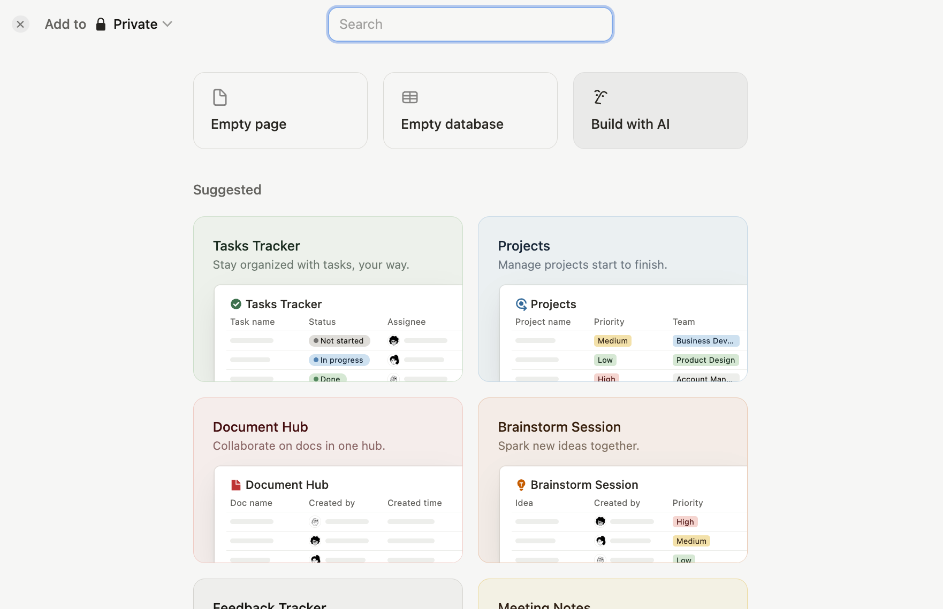

### **Option 1: Setting Up Your Signal Inbox in Notion (Manual)**

1. **Create a new page** called "Market Intelligence" or "Signal Inbox"
2. **Create a database**: Type /database and select "Table - Inline"
3. **Set up your core properties**:
   * **Signal Title** (Title): A short descriptive title for the signal
   * **Date Observed** (Date): When you encountered this signal
   * **Digital Sense** (Select): Which of the five senses captured this signal
   * **Signal Type** (Select): Categories like Trend, Customer Comment, Competitor Move, etc.
   * **Source** (Select): Where you found this signal (Reddit, TikTok, Customer Interview, etc.)
   * **Raw Content** (Text): The actual text, description, or reference to what you observed
   * **Attachments** (Files & Media): Screenshots, images, or media related to the signal
   * **Emotional Tone** (Select): The dominant emotion expressed (Excitement, Frustration, etc.)
   * **Relevance** (Select): Low, Medium, High to indicate importance
   * **Notes** (Text): Any additional context or thoughts you want to add
4. **Create Views for different perspectives**:
   * **All Signals** (Table View): Everything in chronological order
   * **By Digital Sense** (Board View): Group by which sense detected it
   * **By Signal Type** (Board View): Group by trend, feedback, competitor move, etc.
   * **High Relevance Only** (Table View): Filter to show only high relevance signals
   * **Recent Signals** (Table View): Only the last 30 days
   * **Visual Gallery** (Gallery View): Image-focused view using the Attachments property
5. **Install the Notion Web Clipper**:
   * <https://www.notion.com/web-clipper>
   * Add the Notion Web Clipper extension to Chrome
   * Configure it to clip to your Signal Inbox
   * Use it to rapidly capture signals while browsing

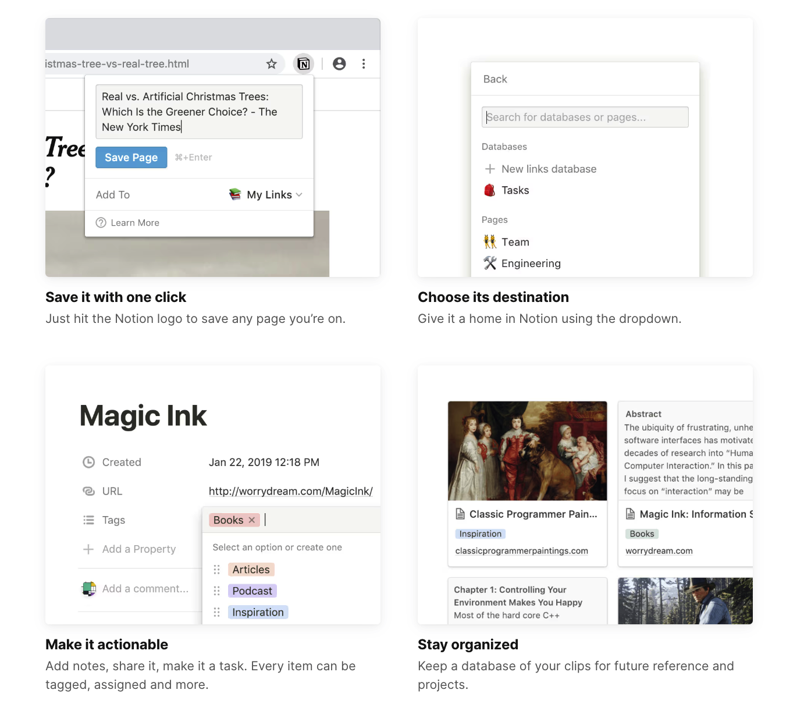

1. **Use Notion AI for quick analysis**:
   * Within any signal entry, type /AI
   * Ask it to summarize the emotional tone
   * Ask it to extract key themes or patterns
   * Ask it to compare to similar past signals

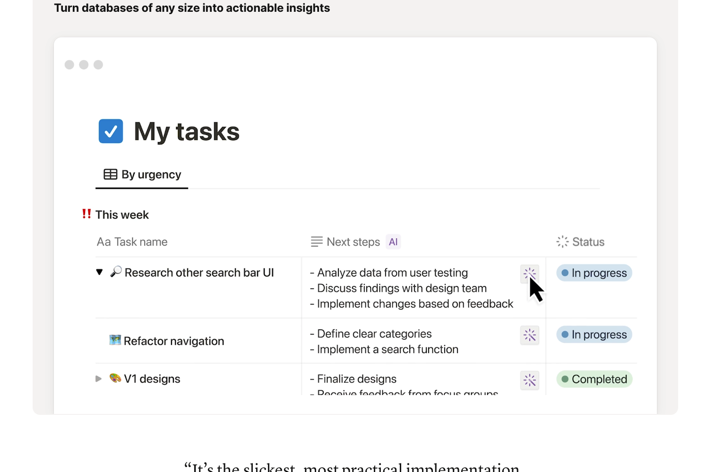

## **Starter Notion Templates (Using it’s AI Builder)**

Here are three starter prompts and a customizable megaprompt designed specifically for creating robust Market Signal Inboxes in Notion.

## **Starter Prompt 1: Basic Market Signal Inbox**

| Create a detailed Market Signal Inbox in Notion with these components:  1. Main Database: Create a table called "Market Signals" with these properties:  - Signal Title (Title property)  - Date Observed (Date property)  - Digital Sense (Select: Digital Sight, Digital Hearing, Digital Touch, Digital Smell, Digital Taste)  - Signal Type (Select: Customer Comment, Competitor Move, Visual Trend, Behavioral Pattern, Terminology Shift, Cultural Shift)  - Source (Select: Social Media, Customer Support, User Testing, Competitor Website, Review Site, Forum)  - Raw Content (Text property)  - Attachments (Files & Media property)  - Emotional Tone (Select: Excitement, Frustration, Anxiety, Confusion, Delight, Disappointment, Trust, Skepticism, Neutral)  - Relevance Score (Number property, 1-5)  - Signal Status (Select: New, Under Analysis, Connected to Pattern, Actioned, Archived)  - Notes (Text property)  - Created By (Person property)  - Created (Created time property)  - Last Edited (Last edited time property)  2. Views:  - Table View: All Signals (default)  - Kanban View: By Digital Sense (group by Digital Sense)  - Kanban View: By Signal Type (group by Signal Type)  - Gallery View: Visual Signals (filtered to show only records with attachments)  - List View: High Priority (filtered where Relevance Score ≥ 4)  - Calendar View: Signal Timeline (date by Date Observed)  3. Template buttons for quick signal entry  4. A linked database for Pattern Recognition  5. Instructions for how to use the Web Clipper to capture signals |
| --- |

## 

## **Starter Prompt 2: Customer Feedback Signal Inbox**

| Create a Customer Feedback Signal Inbox in Notion with these components:  1. Main Database: Create a table called "Customer Feedback" with these properties:  - Feedback Title (Title property)  - Date Received (Date property)  - Channel (Select: Email Support, Live Chat, Phone, Social Media, App Store, Review Site, NPS Survey, User Testing)  - Customer Identifier (Text property)  - Customer Segment (Select: New User, Established User, Power User, Enterprise, SMB, Freemium, Churned)  - Feedback Category (Select: Product Feature, UX/UI, Performance, Pricing, Customer Service, Onboarding)  - Feedback Type (Select: Bug Report, Feature Request, Praise, Complaint, Question, Suggestion, Cancellation Reason)  - Verbatim Feedback (Text property)  - Attachments (Files & Media property)  - Sentiment (Select: Very Negative, Negative, Neutral, Mixed, Positive, Very Positive)  - Impact Level (Number property, 1-5)  - Action Required (Checkbox property)  - Follow-up Status (Select: No Action Needed, Needs Response, Response Sent, Needs Escalation, Resolved)  - Assigned To (Person property)  - Resolution Notes (Text property)  2. Views:  - Table View: All Feedback (default)  - Kanban View: By Follow-up Status (group by Follow-up Status)  - Board View: By Channel (group by Channel)  - Board View: By Sentiment (group by Sentiment)  - List View: Action Required (filtered where Action Required is checked)  - Calendar View: By Date Received  3. Template buttons for common feedback types  4. Relations to product database (if applicable)  5. Forms for team members to quickly add feedback |
| --- |

## 

## **Starter Prompt 3: Competitive Intelligence Signal Inbox**

| Create a Competitive Intelligence Inbox in Notion with these components:  1. Main Database: Create a table called "Competitor Signals" with these properties:  - Signal Title (Title property)  - Date Observed (Date property)  - Competitor (Select: add your main competitors)  - Signal Category (Select: Product Launch, Feature Update, Price Change, Positioning Shift, Marketing Campaign, Partnership, Expansion, Funding, Leadership Change)  - Source Type (Select: Company Website, Press Release, Social Media, Industry News, Customer Report, Sales Conversation)  - Source URL (URL property)  - Signal Description (Text property)  - Evidence (Files & Media property)  - Potential Impact (Select: No Impact, Low Impact, Moderate Impact, High Impact, Critical Threat, Opportunity)  - Impact Timeframe (Select: Immediate, Short-term, Medium-term, Long-term)  - Product Areas Affected (Multi-select: add your product areas)  - Strategic Response Required (Checkbox property)  - Response Owner (Person property)  - Response Status (Select: No Response Needed, Monitoring, Planning Response, Executing Response, Completed)  - Response Notes (Text property)  2. Views:  - Table View: All Signals (default)  - Board View: By Competitor (group by Competitor)  - Board View: By Signal Category (group by Signal Category)  - List View: High Impact (filtered where Potential Impact is High Impact or Critical Threat)  - List View: Requires Response (filtered where Strategic Response Required is checked)  - Timeline View: Competitor Movements (date by Date Observed)  - Gallery View: Visual Evidence (for signals with attachments)  3. Template buttons for different signal types  4. Linked database for Strategic Responses  5. Relations to company insights database |
| --- |

## 

## **Customizable Megaprompt for Notion Market Signal Inbox**

This template helps you create a custom Notion database tailored to your specific market intelligence needs. Fill in your details, then ask your preferred AI to generate a complete setup guide.

| Please help me create a detailed Market Signal Inbox in Notion based on my specific requirements:  Business Context: [ENTER: Brief description of your industry, company, target market, and key competitors]  Primary Purpose: [ENTER: What you mainly want to track - customer feedback, market trends, competitor movements, etc.]  Signal Sources: [ENTER: Where your signals will come from - social platforms, customer support, sales conversations, review sites, etc.]  Signal Collection Method: [ENTER: Manual entry, Notion Web Clipper, forms, API integrations, etc.]  Please provide a complete setup guide for Notion with:  1. Database Structure:  - A main "Market Signals" table with these properties:  * Signal Title (Title property)  * Date Observed (Date property)  * Digital Sense (Select with: Digital Sight, Digital Hearing, Digital Touch, Digital Smell, Digital Taste)  * Signal Type (Select with categories relevant to my business)  * Source (Select with my signal sources)  * Raw Content (Text property)  * Attachments (Files & Media property)  * Emotional Tone/Sentiment (Select with appropriate options)  * Relevance/Impact Score (Number property)  * Signal Status (Select with processing stages)  * [ADD: Any additional custom properties needed]  * Notes (Text property)  2. Views Configuration:  - Table View: All Signals (chronological)  - Board View: By Digital Sense (grouped)  - Board View: By Signal Type (grouped)  - List View: High Relevance/Impact (filtered)  - Gallery View: Visual Signals (for attachments)  - Timeline View: Signal Evolution  - [ADD: Any other view types needed]  3. Template Buttons:  - Quick signal entry templates for different signal types  - Template for detailed competitor analysis  - Template for customer feedback processing  4. Related Databases and Connections:  - A "Patterns & Themes" database to connect related signals  - Integration with other company databases  - [ADD: Any specific database relations needed]  5. Workflow Automation:  - Web Clipper setup instructions for signal capture  - Notion AI implementation for signal analysis  - [ADD: Any specific automation needs]  Please provide step-by-step instructions with real examples tailored to my context, focusing on both setup and practical daily use of the system. |
| --- |

## **Example Signal Entries**

To help you understand what good signal entries look like, here are some examples across different digital senses:

### **Example 1: Digital Sight Signal**

**Signal Title**: Competitors shifting to earthy color palettes **Digital Sense**: Digital Sight **Signal Type**: Visual Trend **Source**: Competitor Websites **Raw Content**: Three competitors in our space (Company A, B, and C) have updated their websites in the past month to use similar earthy, desaturated color schemes with lots of browns and greens, moving away from brighter blues. **Emotional Tone**: N/A **Relevance Score**: 4 **Notes**: Possible connection to sustainability messaging? All three are also emphasizing eco-friendly credentials more prominently.

### **Example 2: Digital Hearing Signal**

**Signal Title**: "Anxiety" replacing "stress" in wellness discussions **Digital Sense**: Digital Hearing **Signal Type**: Linguistic Shift **Source**: Reddit **Raw Content**: "I've noticed people in r/wellness increasingly using 'anxiety' instead of 'stress' when describing their emotional state. Threads about 'anxiety management' are getting 3x the engagement of 'stress management' posts, and commenters often correct posters who use 'stress' by saying 'what you're describing is anxiety.'" **Emotional Tone**: Concern **Relevance Score**: 5 **Notes**: This might indicate a deeper shift in how people conceptualize their mental health - from external pressures (stress) to internal states (anxiety). Worth exploring how our messaging should adapt.

## **Signal Collection Workflow**

To make signal collection a consistent habit, establish a workflow that includes:

1. **Regular scanning sessions**:
   * Schedule 15-30 minutes daily to scan key sources
   * Rotate which digital sense you focus on each day
2. **In-the-moment capture**:
   * Use the Notion Web Clipper or Airtable form for instant capture
   * Create mobile shortcuts for quick entry from your phone
3. **Signal triage**:
   * Review new signals weekly
   * Add relevance scores
   * Look for connections between signals
   * Add notes with additional context
4. **Team collaboration**:
   * Share the Signal Inbox with relevant team members
   * Create a Slack channel for sharing potential signals
   * Establish a "signal of the week" discussion

📸 **[SCREENSHOT IDEA]**: Visual workflow diagram showing the signal collection process

## **Preparing for the Next Stage: Your Second Brain**

While this guide focuses on setting up your Signal Inbox, it's good to understand how it will connect to your Market Second Brain - the next stage in your intelligence system.

Your Signal Inbox captures raw, unprocessed signals. Your Second Brain will:

* Organize signals into meaningful patterns
* Connect signals across time and sources
* Layer in Mind, Heart, and Gut intelligence
* Transform signals into actionable insights
* Store everything in a retrievable, evolving knowledge system

We'll cover this in detail in the next lesson, but for now, make sure your Signal Inbox is set up to flow smoothly into that next stage.

## **Next Steps**

Now that you've set up your Market Signal Inbox:

1. **Populate with initial signals**: Aim for 15-20 signals across all five digital senses
2. **Experiment with views**: Create the views that make the most sense for your specific needs
3. **Establish collection habits**: Set up your daily/weekly signal collection routine
4. **Prepare for automation**: Consider how you might eventually automate parts of your signal collection (we'll cover this in the Automation module)

In the next lesson, we'll build your Market Second Brain - the system that transforms these signals into patterns, insights, and strategic intelligence.